Nopef  Nordic Environment Finance Corporation (Nefco)  Street address : Fabianinkatu 34  Mail : PO Box 241, FI-00171 Helsinki  Finland  Tel. +358 10 618 003  firstname.lastname@nefco.int  www.nopef.com |   Please give complete and accurate answers. Write in the grey fields The application form does not need to be signed physically.  Please send the application as a Word document, with financial reports, company registration documentation and other relevant attachments by e-mail, to: info@nopef.com  Applications are registered on an ongoing basis and are considered in accordance with the timetable listed on Nopef's website.

APPLICATION FOR CONDITIONAL LOAN FOR INTERNATIONALISATION
This application is for a conditional loan of up to 50 % of approved costs in connection with a feasibility study (step one) for an internationalisation project (step 2) outside the EU/EFTA-area, such as the establishment of a subsidiary or Joint Venture, the implementation of a demonstration project or pilot installation, or for a comparable long-term establishment and investment in the project country.
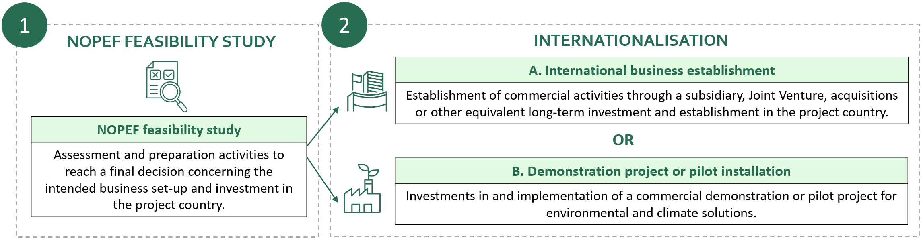
• Nopef offers financing in the form of interest-free conditional loans for internationalisation to Nordic small and medium-sized enterprises with a maximum turnover of EUR 50 million and a maximum of 249 employees. The conditional loan is disbursed against actual incurred costs provided in a cost report controlled by an auditor. The disbursed conditional loan is converted into a grant, wholly or partially, when a final project report and cost reporting have been approved.
• All projects supported by Nopef shall contribute to positive environmental or climate impacts (link for more info).
• The applying company is required to have at least one full year of operational activity, necessary financial and other resources to carry out the project, as well as commercialised products or services based on proven technology.
• Supported projects shall also contribute to Nordic benefit. Projects that contribute directly to the goals of the Nordic Vision 2030 can be given priority by Nopef (link for more info).
• The maximum amount of financing from Nopef is EUR 50 000. Nopef can cover up to half of the approved feasibility study budget.
• Funding from Nopef is paid out in accordance with the EU de minimis regulation which allows for payments of state aid provided that the total amount per recipient does not exceed EUR 300,000 over a period of three fiscal years. Nopef is administered by the Nordic Environment Finance Corporation (Nefco) and has zero tolerance with regard to corruption.
For more information, please visit www.nopef.com

PART 1 - Contact information

Applicant company information
Business ID (Organisationsnummer (SE), Y-tunnus / FO-nummer (FI), Organisasjonsnummer (NO), CVR-numre (DK inkl. GL), Kennitala (IS), Skrásetingar-nr. (FO))
Company Name
Street address
PO Box
Postal code
City
Country
Website
Phone

Managing Director
Name
Email
Phone

Company contact person
Name
Job title
Email
Phone

Company financial manager
Name
Job title
Email

Company responsible auditor
Name
Firm of auditors
Email

Consultancy services - if a business consultant is contributing to this application and the reporting of the feasibility study.
Name of consultant
Company
Email
Phone
☐ Yes, the consultant shall receive information related to the feasibility study from Nopef (report reminders, application decisions etc.)

PART 2 - Company information

2.1. Company information
Establishment year
Industry | If other industry, which:
Turnover latest financial year | Applicant company:  Group (if applicable):
Number of employees | Applicant company:  Group (if applicable):

2.2. Owners and ownership share
Specify all legal entities and persons with minimum 10% direct or indirect shareholdings. If the company is part of a group, provide a capitalisation table as a separate annex to the application.
Name | Type (holding company, founder, investor, etc) | Ownership share %
TOTAL |  | 100%

2.3 Gender distribution
Name | Number of men | Number of women
Gender distribution in the company:
Gender distribution of the board:

  - Description of company – approx. 1 page

A full description of the applicant company and its business concept, recent history, ownership and management, company structure and subsidiaries, products and services, market and competition (market areas, sales channels, clients, competitors), production equipment (own or rented facilities), machinery set-up, new investments, technology, staff resources, subcontractors, etc. Describe strategic plans and objectives, such as developing new products, new markets, internationalisation, etc.

Business concept

Recent history

Ownership and management

Company structure and subsidiaries

Products and services

Market and competition (market areas, sales channels, clients, competitors)

Production equipment (own or rented facilities), machinery set-up, new investments, technology, staff resources, subcontractors, etc.

Strategic plans and objectives, such as developing new products, new markets, internationalisation, etc.

PART 3 - Information about the planned internationalisation
This section shall describe the international activities (step 2) that the feasibility study (described in section 4) is to prepare and assess.
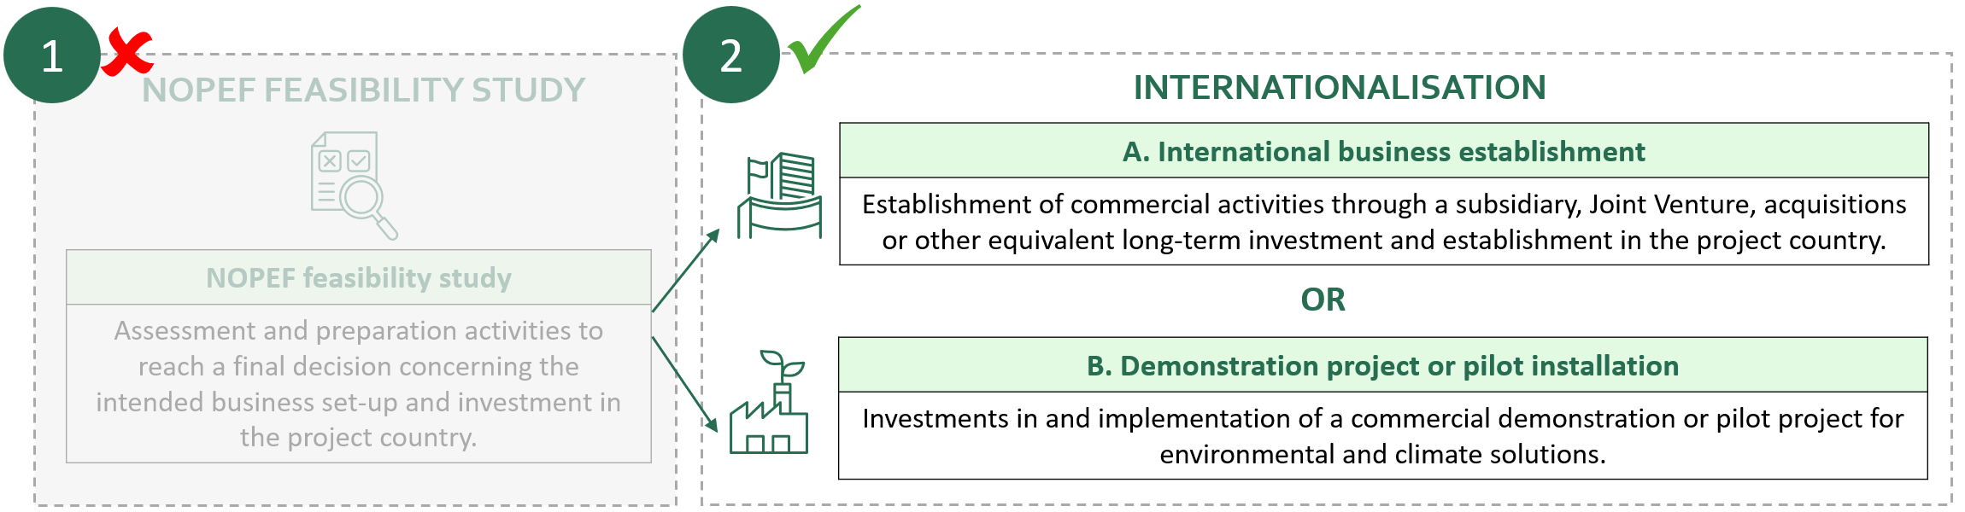

3.1 Target country
Specify which country the planned internationalisation refers to.

Summary of the objectives (Max 50 words)
Provide a summary of the objective(s) for the planned internationalisation

Type of internationalisation
Specify the primary aim of the feasibility study. Choose only one alternative.
International establishment refers to the establishment of commercial activities through a subsidiary, Joint Venture, acquisitions or other equivalent long-term investment and establishment in the project country.
Demonstration project or pilot installation refers to the investment in and implementation of Nordic environmental and climate solutions in the project country.

Note: a written statement, which confirms the local project partner’s interest to implement a demonstration project or pilot installation shall be included with this application.

Implementation of the planned internationalisation
Answer only A or B below depending on the type of internationalisation indicated in question 3.3.

- International establishment – approx. 1- 2 pages
Describe the background, business idea, identified business opportunity and main objectives, including
- the rationale behind the planned internationalisation
- reasons for choice of project location
- the business concept in the target country and commercial targets
- envisioned market strategy, business model, prospective customers and targeted sector(s), existing competition in the country, financial and operational objectives, etc.
- the planned business model and business units
- the planned legal structure of the local organisation and ownership distribution
- potential partners and their roles and responsibilities in the planned establishment, other participants and their interests
- if applicable, describe the different implementation phases of the establishment

The rationale behind the planned internationalisation

Reasons for choice of project location

The business concept in the target country and commercial targets

Envisioned market strategy, business model, prospective customers and targeted sector(s), existing competition in the country, financial and operational objectives, etc.

The planned business model and business units

The planned legal structure of the local organisation and ownership distribution

Potential partners and their roles and responsibilities in the planned establishment, other participants and their interests

If applicable, describe the different implementation phases of the establishment

B.1 Demonstration project or pilot installation – approx. 1 page
Describe the background, business idea, identified business opportunity and main objectives, including:
- the rationale behind the planned internationalisation
- reasons for choice of project location
- business concept in the target country
- commercial targets and outcomes if the project is successful

The rationale behind the planned internationalisation

Reasons for choice of project location

Business concept in the target country

Commercial targets and outcomes if the project is successful

B.2 Local project partner and implementation – approx. 1-2 pages
Specify:
- the local project partner and its area of expertise
- responsibilities, functions and roles of the partner(s) in the project (commercial interest and funding)
- a detailed description of activities and processes involved in the demo or pilot
- technical and operational details
- other potential partners involved and their role in the demonstration or pilot project
- time frame of implementation
- potential phases for the implementation of the pilot/demo, etc.
- where the pilot installation or demonstration project is planned to be implemented

The local project partner and its area of expertise

Responsibilities, functions and roles of the partner(s) in the project (commercial interest and funding)

A detailed description of activities and processes involved in the pilot/demo

Technical and operational details

Other potential partners involved and their role in the demonstration or pilot project

Time frame of implementation

Phases for the implementation of the pilot/demo

Location of the pilot installation or demonstration project

Demonstration value – approx. ½ page
Describe how the planned internationalisation contributes to the demonstration and scale-up of Nordic environmental and climate technology/solutions on global markets.

Investment budget and financing plan for the planned internationalisation
The investment budget and financing plan in this section refers to the planned internationalisation and should not include costs for the feasibility study. The costs for the feasibility study are specified in section 4.6.
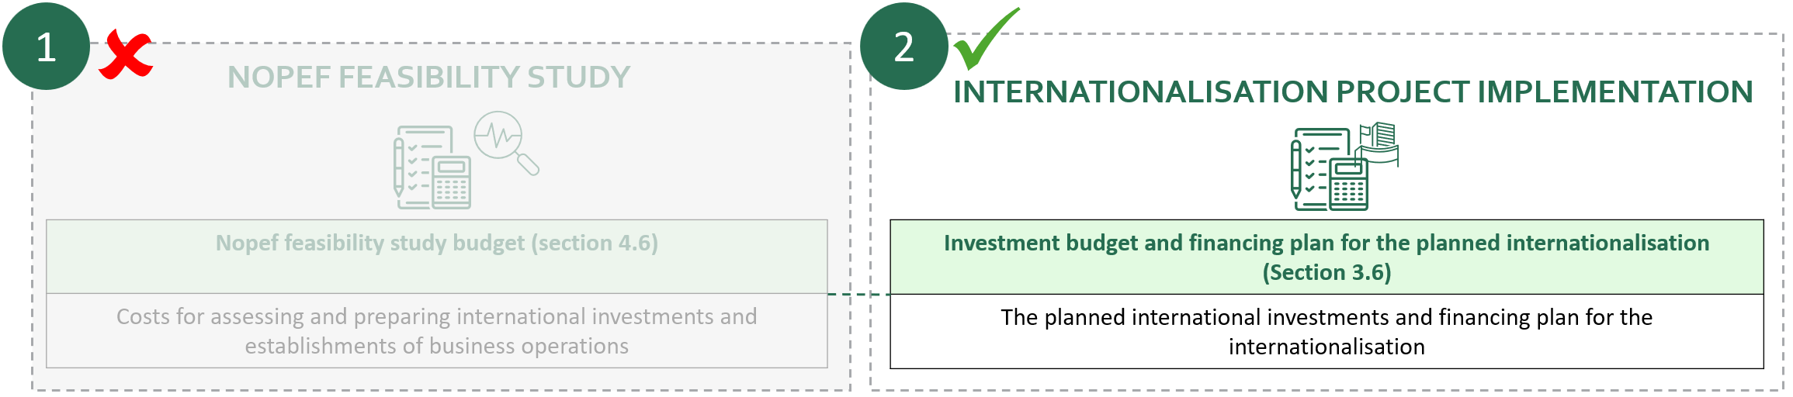

3.6.1 Investment budget for the planned internationalisation
Present a preliminary investment budget for the planned internationalisation. The investment budget should specify the planned investments in the project country and home country, including the costs for the start-up phase, installations and operating costs during:
- the first year of operation (A. International establishment)
OR
- for the duration of the B. demonstration project / pilot installation.
Comment
Share capital, purchase of company/share in JV
Facilities and renovation
Machines and equipment
Installations
Start-up costs
Training and transfer of competence
Quality certification and licenses
Salaries and consultants
Other
Total investments

3.6.2 Financing plan for the planned internationalisation
The financing plan should describe the total financing needs for the planned internationalisation, including the need for loans, external investors, share issue, public financing, etc. Note: The financing plan amount must match the total investment budget and shall not include the Nopef funding, which is only for feasibility study costs (section 4.6).
Comment
Own funds
New equity offering
Shareholder loans
Bank loans
Partner company financing
Other financing
Capital contribution in kind
Total financing
We are interested in discussing further financing from Nefco (fund manager of Nopef) for the planned internationalisation. Please see available financing options from Nefco on the website.

3.6.3 Additional information on how the company intends to secure the required funding
If the internationalisation to a large extent is dependent on new equity capital or external debt financing, the applicant company should provide details below and provide a written financing statement, Letter of Intent or similar, which verifies the investor's intent to participate.

PART 4 – NOPEF Feasibility study for internationalisation
This section shall describe the feasibility study (step 1) that aims to prepare and assess the internationalisation project (described in section 3).
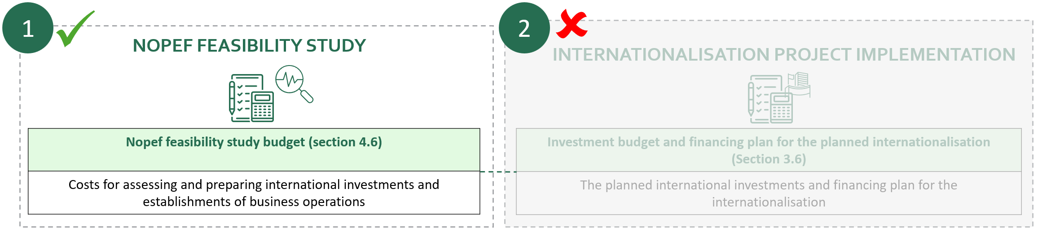

4.1 Estimated starting date and completion date of feasibility study
Specify when the feasibility study is expected to start and end, resulting in the planned internationalisation (establishment or start of pilot or demonstration project).
Estimated starting date (MM/YY):
Estimated completion date (MM/YY):

4.2 Feasibility study plan - approx. 1 page
Describe the aim of the feasibility study and list
- the scope of the feasibility study and aspects of the internationalisation to be explored
- the activities included and how they contribute to the decision regarding the planned internationalisation
- the key milestones in the feasibility study
Describe
- identified risks and problem areas to be addressed
- key persons as well as their role in the feasibility study
- project partner(s) role in the feasibility study (if applicable)

Scope of the feasibility study and aspects of the internationalisation to be explored

Activities included and how they contribute to the decision regarding the planned internationalisation

Key milestones in the feasibility study

Identified risks and problem areas to be addressed in the feasibility study

Key persons and their role in the feasibility study

Project partner(s) role in the feasibility study (if applicable)

Nopef’s added value and additionality – approx. ½ a page
- How will Nopef’s participation have a positive impact on the implementation, time schedule, scope, and decision to implement the feasibility study?
- Will the feasibility study be implemented without the support from Nopef?
- Are there other benefits of Nopef’s participation?

4.4 Has other public financing been granted for conducting the feasibility study?
No Yes, granted amount and name of donor(s):

4.5. Guidelines for the feasibility study budget
Nopef can finance up to 50 % of approved feasibility study expenses. See: "Costs covered by Nopef’s grant" on Nopef's website (link) or contact Nopef to discuss with a case handler before filling in the feasibility study budget.

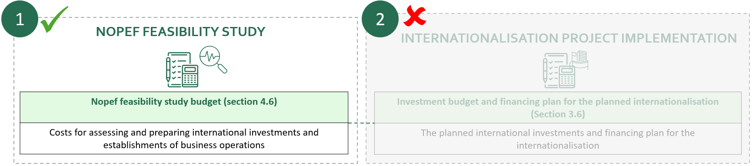

- Approved costs, which can be included in the feasibility study budget include internal personnel expenses, travel costs, legal and financial advice, consultants, etc. Minor costs related to the feasibility study, such as mail, telephone, car rental or accommodation can also be included in the feasibility study budget.

- Feasibility study funds are not granted for marketing, sales, research and development, purchase of equipment/machinery, or for normal operating activities.

- Personnel expenses are direct, paid salaries and payroll expenses/social security contributions. Wages must be based on a cost, not at the market price that is invoiced to customers. Hourly rates shall be calculated as monthly salary expenses divided by 160 hours. Staff contributions in the feasibility study must be based on verifiable time lists.

- Travel between the home country and project country can be included. Travel within the country of origin or to a third country must be justified.

- Nopef supports consulting and legal fees related to the feasibility study. Nopef covers the cost of the external experts' work efforts and travel. Fees for an auditor review of the cost reporting may be included in the budget.

4.6 Feasibility study budget
Choose currency for feasibility study budget
1. Applicant company's internal personnel expenses
Name / Task in the feasibility study | Hours / Hourly rates for personnel |  |  | Expense amount
/ | /
/ | /
/ | /
/ | /
/ | /
/ | /
/ | /
/ | /
 |  | Subtotal
2. Travel expenses
Name / Task in the feasibility study | Destination (country) |  |  | Expense amount

/

/

/

/

/

/

/

/
 |  | Subtotal
3. Expenses for external services (consultants, financial advice, lawyers, etc.)
Company | Nature of work |  |  | Expense amount
 |  | Subtotal
4. Other expenses relating to the feasibility study
Specification |  |  |  | Expense amount
 |  | Subtotal
 |  |  | Total:

PART 5. Nordic interest and added value
5.1 Nordic partners and Nordic collaboration
Nopef gives priority to applications that involve Nordic partners and collaborators from two or more Nordic countries, including the applicant company. Nordic partners can refer to Nordic companies, co-financiers, organisations, institutions, or other private and public entities that directly participate in or contribute to the project.

- Specify the Nordic partners, their home country and role in the feasibility study and subsequent internationalisation

5.2 Nordic subcontractors
Specify your Nordic subcontractors that may benefit indirectly if the internationalisation is successful.
Country | Name of company/ies | Product/service
Denmark
Finland
Iceland
Norway
Sweden

5.3 Impact on Nordic job creation, exports and competitiveness
Describe the impact on Nordic job creation, exports and competitiveness the internationalisation is expected to generate:
- Indicate the number of jobs the internationalisation is expected to create in the Nordic countries and the project country. Specify the types of roles (e.g., managerial, technical, operational), and provide a timeline for when these jobs are expected to materialize (e.g., within 1, 3, or 5 years).
- Describe and quantify the anticipated increase in sales and investment opportunities, both in the Nordic countries and the project country, that the internationalisation is expected to generate. Include projected figures and a timeline for achieving these results.

5.4 Impact on equality
- Does the applicant company have clear processes/plans on how to contribute towards equality within their business operations?
- How is equality addressed in the internationalisation project? Aspects such as equal opportunity, equal renumeration, etc.
- Is the project expected to promote equality in the project country or in the Nordics?

PART 6. Environmental impact of the planned internationalisation
Describe the potential impacts of the planned internationalisation regarding applicable environmental objective(s). Provide information under each relevant environmental objective below. If not relevant, please mark ‘N/A’.

6.1 Climate change mitigation
For example, renewable energy production, increasing energy efficiency, clean and carbon-neutral mobility, carbon capture and utilisation/storage, strengthening land carbon sinks, switching to the use of renewable materials, production of clean fuels and activities enabling substantial greenhouse gas emissions reductions in other sectors (such as establishing energy infrastructure required for enabling the decarbonisation of energy systems). Describe:
- Positive impacts
- Possible adverse impacts and planned measures to mitigate these (For example, significant increase of GHG emissions, significant long-term reduction of carbon sinks)

6.2 Climate change adaption
For example, reducing material physical climate risks, reducing vulnerability and building resilience of a wider system such as a community, ecosystem or city, or supporting/enabling adaptation by others.
Describe:
- Positive impacts
- Possible adverse impacts and planned measures to mitigate these (For example, hindering adaptation efforts by others; people, nature or assets or hamper adaptation elsewhere.)

6.3 Sustainable use and protection of water and marine resources
For example, improving good ecological potential of water bodies (surface water, groundwater) and environmental status of marine waters. Describe:
- Positive impacts
- Possible adverse impacts and planned measures to mitigate these (For example, activity being detrimental to the status/ecological potential of water bodies, risks related to water quality and consumption)

6.4 Transition to circular economy
For example, resource efficiency, waste and by-product management, recycling. Describe:
- Positive impacts
- Possible adverse impacts and planned measures to mitigate these (For example, inefficiencies in the use of materials and the direct or indirect use of natural resources.)

6.5 Pollution prevention and control
For example, preventing pollution to air, water, soil. Describe:
- Positive impacts
- Possible adverse impacts and planned measures to mitigate these (For example, an increase in emissions, discharges into air, water or land.)

6.6 Protection and restoration of biodiversity and ecosystems
For example, conservation of habitats and species. Describe:
- Positive impacts
- Possible adverse impacts and planned measures to mitigate these (For example, the activity is detrimental to the good condition and resilience of ecosystems or to the conservation status of habitats and species.)

6.7 Quantification of environmental impact
Present quantitative estimates for the positive environmental effects that the planned internationalisation is expected to result in. For example: energy consumption saved (MWh/year), reduced water usage (tonnes/year), emission reduction (e.g. tonnes of CO2 eq./year). Specified as actual or percentage change. If applicable, describe relevant reference projects with achieved results.

PART 8. Mandatory appendices
Latest audited annual financial statement (including auditor’s statement)

Interim figures if the latest financial records are older than six (6) months - Profit and loss statement and balance sheet

The Group’s latest audited annual financial statement - If the applicant company is majority owned by a group

Applicant company’s certificate of registration documents - Firmaattest fra foretaksregisteret (NO), Utdrag ur Handelsregistret/Kaupparekisteriote (FI), Registreringsbevis (SE), Tegningsudskrift fra Erhvervs- og selskabsstyrelsen (DK), Certificate of Registration from the Skráasvið – Register of Enterprises (IS)

Letter of Intent (if applicable) - Provide one or several Letter of Intent (LoI) from investors (if the planned investment to a large extent is dependent on external financing), from the parent company (if the applicant company is a subsidiary of a company that will finance the planned internationalisation), or from other prospective partner companies.

Invitation to implement a pilot installation or demonstration project from local partner (ONLY for applications concerning B. Demonstration or pilot installation projects): LoI, MoU or other written documentation that confirms the identified local partner's interest for the applicant company to implement a demonstration project or pilot installation.

PART 9. Disclosure policy
The Lender reserves the right to publish the Borrower’s name after the conditional loan is granted.

PART 10. Information about de minimis aid
Conditional loans provided by The Nordic Project Fund are paid out in accordance with EU:s de minimis regulation for state aid, which allows for payments of state aid provided that the total amount per recipient does not exceed EUR 300,000 over any period of three years, calculated from the date when the conditional loan by Nopef is granted.

I have read and agree to the terms laid out in Nefco’s privacy policy (link).
As CEO or other representative authorised to sign on behalf of the company, I hereby declare that the information given on this form is true and correct

Place and date | Name and job title

Please send the application as a Word document, with financial reports, certificate of registration documents and other relevant attachments by e-mail, to: info@nopef.com

If your company is not required to have an auditor, please provide the contact details of your company accountant. Please note that Nopef requires audited cost reporting in connection with a disbursement request.

